Name:
Professor:
Course:
Date:
Compare and Contrast Wind Sculpture by Yinka Shonibare and
Preying Mantra by Wangechi Mutu
Yinka Shonibare’s Wind Sculpture is one of the most interesting artworks that addresses the theme of invisibility and movement. The sculpture focuses on showing the invisible and yet powerful strength of the wind as shown in the movement of the fabric. Another work of art that explores a similar theme is the Preying Mantra by Wangechi Mutu. The Preying Mantra focuses on exploring the fantasy world of females and how they use their geometric pattern to camouflage themselves. This art takes on the posture of a praying mantis camouflaged in its habitat for security and in the pursuit of happiness.
The Wind Sculpture and the Preying Mantra have several similarities as well as differences identified in the process of analyzing the theme of invisibility. One of the similarities is that both works used to evoke a sense of freedom and possibility. In Shonibare’s sculpture, the fabric is painted portraying dynamic movements as a result of the wind. The force of the wind prompts the fabric to take on a voluptuous shape, causing a movement that defies gravity. Similarly, dynamic movements are used in Mutu’s artwork. Preying Mantra shows a female figure that is reclined on a geometric shape spread in the tree branches. The figure is shown to be in a relaxed posture, with a blanket on her underside. The position on the tree also shows her ability to defy the force of gravity.
Another similarity between these works is that they use color carefully, and in a balanced manner to capture the essence of nature, originality, and balance. The Wind Sculpture uses different colors, which are richly layered and related to each other. Color is also used in Mutu’s work to show different cultures, and more importantly compliment nature. The use of color is also used to show how the natural and unnatural phenomena are linked to each other.
Both works are a clear representation of the relationships between past and modern cultures, and how they have affected lifestyles of Africans. Shonibare uses the fabric to show the relationships between original and hybrid traditions. Similarly, this is addressed in Mutu’s work, where she shows the position of women in the Kenyan society before and after the arrival of the colonialists.
A major difference between the pieces of art is that, the Preying Mantra employs the use of a female figure on a tree, with fabric that matches the colors of the tree. Through this approach, the artist achieves camouflage (the theme of invisibility). On the other hand, invisibility in the Wind Sculpture is achieved by showing movements of the fabric due to the force of the wind. Another difference can be seen in brightness and contrast between the colors used. Each artwork uses different colors, which show the type of environment and its impacts on lifestyle. The balance of colors in the Wind Sculpture shows how African and Indonesian traditions have been integrated. On the other hand, the contrasting colors in the Preying Mantra are an indication of the differences between African and Western traditions.
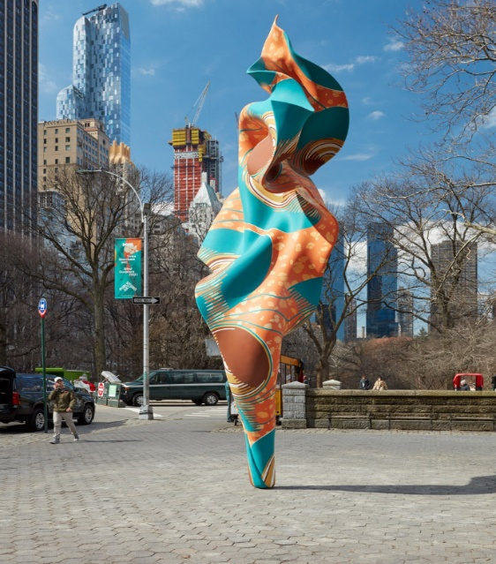
Wind Sculpture by Yinka Shonibare. (Doris C. Freedman Plaza).
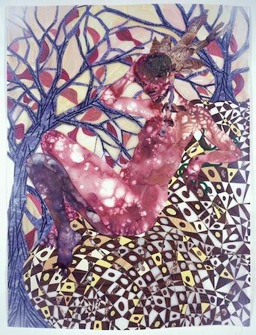
Wangechi Mutu, Preying Mantra, 2006, mixed media on mylar (Brooklyn Museum).

Works cited
Freedman, Doris. C. Yinka Shonibare MBE: Wind Sculpture (SG). (2018). Available at https://www.publicartfund.org/exhibitions/view/yinka-shonibare-mbe-wind-sculpture-sg-i/#section_2
Harris, Shawnya. Wangechi Mutu, Preying Mantra. (2020). Available at https://www.khanacademy.org/humanities/ap-art-history-global-contemporary-apah/21st-century-apah/a/wangechi-mutu-preying-mantra

